GULISTAN & TURGUT OZAL EDUCATIONAL INSTITUTIONS
INFORMATICS LESSON PLAN

DATE :
DURATION : | 40 minutes
GRADE LEVEL: | 10th Class
SUBJECT : | Managing Information: Sorting and Filtering Lists
OBJECTIVES : | To understand and to be able to manage Information Lists

LESSON PLAN
Key words:
Materials used: | Microsoft Excel 2003 Book, Computer
Warm-up questions:

Introduction and explanation of the lesson;

SORTING
Sorting means putting or arranging items in order, according to some criteria. Sorting is commonly used with lists. In many conditions, you prepare lists and put them in order. Microsoft Excel provides an easy feature to put the items in order; the Sort dialog box.
 You can click on a cell in the range that you want to sort. Excel will automatically determine the extent of the list. If you don’t want to include an entire list and want to sort only a part of it, after selecting the range of cells which you want to sort, click the Sort command from Data menu to display the Sort dialog box.
 Click on the Sort by down arrow to select the column you want to sort.
 Click on the Ascending or Descending radio button.
 If you want to use more than one criterion, you can use Then by to sort using more criteria.
 Click Header row to exclude the first row from the sort, if your list has column labels in the uppermost row. Click No header row to include also the first row in the sort, if the list doesn’t have column labels in the uppermost row.
You can also use the Standard toolbar Sort ascending or Sort descending buttons, to do all of the process above with a single click. However, it does not always give the desired result. For accurate results, it is better to use the Sort window.
The Options button lets you specify a custom sort order, such as Low, Medium, High, or Jan, Feb, Mar, so forth. For the column selected in the Sort by box, you can also specify a case-sensitive sort and sort either from top to bottom or from left to right.

FILTERING
Filtering is a quick and easy way to find and work with a subset in a data list. A filtered list displays
only the rows that meet the criteria you specify for a column. Microsoft Excel provides two commands for filtering lists:
 AutoFilter, which includes filter by selection, for simple criteria
 Advanced Filter, for more complex criteria Filtering does not rearrange a list. Filtering
temporarily hides rows which don’t meet the criteria. When Excel filters rows, you can edit,
format, chart, and print your subset list without rearranging or moving it.

AUTOFILTER
When you use the AutoFilter command, arrows appear to the right of the column labels in the
filtered list. AutoFilter puts all the different column items together, and you select the one to be
listed.
You can use Custom AutoFilter to display rows with more complicated filtering conditions. Custom
AutoFilter lets you display rows that meet more than one condition for a column.

ADVANCED FILTER
The Advanced Filter command can filter a list in place like the AutoFilter command, but it does not display drop-down lists for the columns. Instead, you type the criteria by which you want to filter in a separate criteria range above the list. A criteria range allows for more complex criteria to be filtered.

The following wildcard characters can be used as comparison criteria for filters when searching and replacing content.

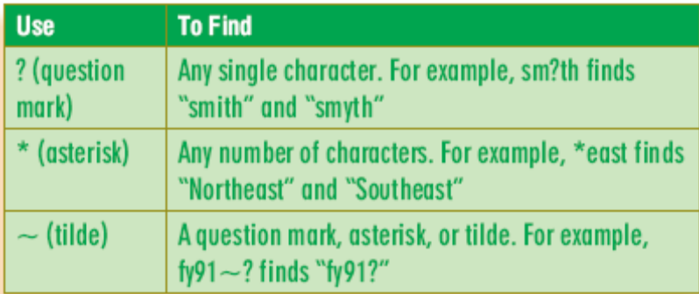

CONCLUSION:

HOMEWORK:

Teacher Director

